 | T.C.  MINISTRY OF AGRICULTURE AND FORESTRY  GENERAL DIRECTORATE OF STATE HYDRAULIC WORKS | 

TURKIYE FLOOD AND DROUGHT MANAGEMENT PROJECT
TERMS OF REFERENCE
FOR
“CONSULTANCY SERVICES FOR REAL-TIME MONITORING OF DROUGHT IN CEYHAN BASIN, GAP ANALYSIS AND PREPARATION OF FRAMEWORK DOCUMENT FOR PILOT PROJECT”

ANKARA– DECEMBER 2025

TABLE OF CONTENTS

ARTICLE 1- GENERAL 1
1.1. Background 1
1.2. Objectives of This Assignment 3
ARTICLE 2 Scope of Works 4
ARTICLE 4- TIMELINE, DELIVERABLES, AND PAYMENT 6
ARTICLE 4- REQUIRED EXPERIENCE AND EXPERTSISE 6
REQUIREMENTS OF FIRM 6
ARTICLE 6- CONTRACT DURATION 8
ARTICLE 8- CONTRACT TYPE 10
ARTICLE 9- REPORTING ARRANGMENTS 10
ARTICLE 8- MISCELLANEOUS 11
TECHNICAL ANNEXES 2

ARTICLE 1 - GENERAL

Background
In general terms, drought and its various forms, defined as the temporary imbalance in regional moisture levels leading to water scarcity, directly or indirectly impact nearly all sectors. In particular, the agricultural sector is highly affected, making the monitoring, prediction, and analysis of drought effects essential for the survival of living organisms and the sustainability of all sectors.
Drought poses a significant challenge for Türkiye, particularly because much of the country already experiences a semi-arid climate. Located within the Mediterranean macroclimate region of the subtropical zone, Türkiye faces considerable year-to-year rainfall variability. This variability leads to regional and widespread droughts of varying intensity, a problem that has been notably exacerbated over the past decade by climate change. As a result, meteorological droughts have become a major contributor to increased water stress in many parts of Türkiye. Semi-arid conditions dominate central, southern, and southeastern regions, where agriculture is the primary economic activity. Looking ahead, climate projections and regional model outputs indicate a substantial decline in precipitation across almost all regions of the country. This trend is expected to increase both the intensity and frequency of drought events. Furthermore, studies suggest that the near future will bring even more arid conditions nationwide.
The Ceyhan Basin is one of Türkiye’s 25 river basins. Extending from the Gulf of Iskenderun into the interior of Central Anatolia, it is situated in the Eastern Mediterranean Region between 36°55' and 38°72' north latitude and 35°45' and 37°81' east longitude. Characterized by steep mountainous terrain and extensive alluvial plains, the basin encompasses the catchment areas of the Ceyhan River and its tributaries. Covering a drainage area of 21,391 km²—about 2.75% of Türkiye’s total surface area, the Ceyhan River itself stretches 509 km. The basin includes parts of the provinces of Kayseri, Osmaniye, Sivas, Adıyaman, Gaziantep, Malatya, Adana, Hatay, and Kahramanmaraş. The region experiences a climate with hot, dry summers and mild, wet winters. Rainfall during the main crop-growing season (June to September) is limited, significantly restricting crop choices and yields unless irrigation is available. In recent years, climate change has intensified drought conditions, further reducing water availability throughout the basin.

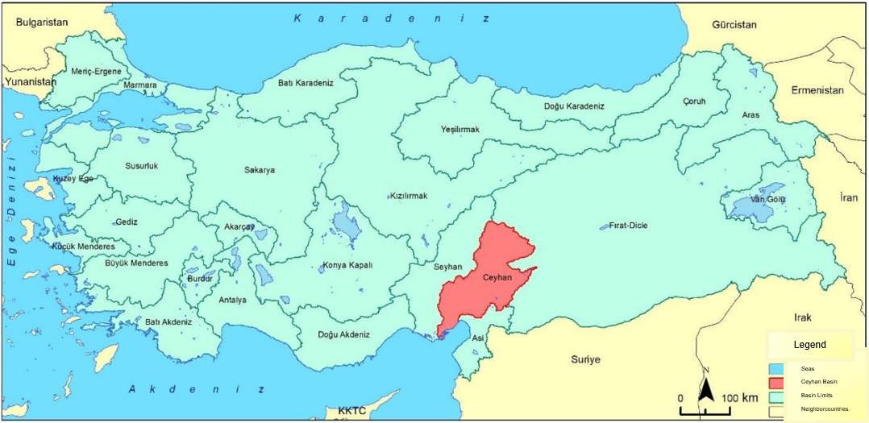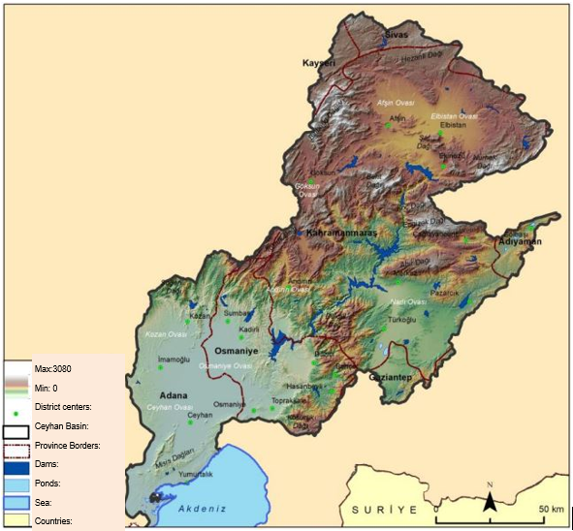
Figure 1. Ceyhan Basin
The Türkiye Flood and Drought Management Project (FDMP) is an important initiative financed by the World Bank, with a total commitment of US$600 million. The project is being implemented by the Directorate General of State Hydraulic Works (DSI) and the Directorate General of Water Management (SYGM). Its primary objective is to enhance flood protection for residents in selected areas of Türkiye and to strengthen the country’s institutional capacity for effective and integrated flood and drought risk management. Component 2 of the FDMP focuses on building DSI’s capacity for drought monitoring and reducing the vulnerability of populations to climate change-induced droughts in selected basins through non-structural measures. This component includes a technical study to evaluate the current state of drought monitoring in Türkiye, identify institutional gaps and overlaps, and develop a framework and action plan for piloting improved drought monitoring in the Ceyhan Basin, with the goal of expanding to other basins. The pilot will involve installing various monitoring stations and developing tools such as drought maps and information platforms to optimize irrigation, improve water use efficiency, and support sustainable agriculture in coordination with relevant agencies.
Following the pilot, an action plan will guide the scaling up of real-time drought monitoring and forecasting systems nationwide, tailored to the specific needs of each basin. Additionally, the component will finance technical studies and consultancy services to design future investments for integrated flood and drought management, such as irrigation modernization, underground water storage, and advanced control systems to mitigate flood and drought impacts. These efforts will be integrated with flood control measures and informed by climate change data, ensuring a comprehensive approach to water resource management and resilience building.

Objectives of This Assignment
The objective of this assignment is (i) to evaluate the current status of drought monitoring in Türkiye, (ii) to identify gaps and overlaps in studies conducted by various institutions (such as DGWM, DGAR, GDM, etc.), (iii) to develop a framework for a pilot study in the Ceyhan Basin, and (iv) to create an action plan to ensure scalability and future expansion to other basins.

ARTICLE 2 - Scope of Works
To achieve the objectives, the consultant is expected to undertake the following tasks:

- Assessment of the Current Status of Drought Monitoring in Türkiye. As part of the evaluation of the current status of drought monitoring in Türkiye, the consultant will review drought monitoring activities conducted by the State Meteorological Services (SMS), the General Directorate of Water Management (DGWM), the General Directorate of Agrarian Reform (DGAR), and other relevant institutions. This assessment will include an examination of legislation, software, and other relevant aspects for drought monitoring. The consultant will identify gaps and overlaps by comparing these existing studies and systems with the requirements of the project.
- Assessment of international best practices. The consultant will conduct a comprehensive review of international best practices in drought monitoring and forecasting systems, evaluating their relevance and applicability to Türkiye. This review will cover global (e.g. FAO), regional (e.g. Copernicus) , and local/national platforms (e.g. US Drought Monitor) and portals, with particular attention to data availability, implemented drought indices, and remote sensing products.

- Options for a technical knowledge exchange: Based on the assessment of international best practices, the consultant will propose candidates for a technical knowledge exchange event. The example to be proposed by the Consultant will be evaluated, and a final decision will be made in consultation with the DSI. Then a technical site visit program will be organized to examine relevant facilities and systems, allowing participants to observe application techniques, gain practical insights, and understand systems that monitor and report drought location, intensity, and impacts. The technical site visit will last at least seven days (excluding travel time) and will include 15 technical personnel from DSI (excluding consultant staff) designated by DSI. The consultant will be responsible for organizing the visits, including selecting institutions and facilities, arranging interviews and briefings, and documenting meetings and outcomes. All organizational expenses for travel and site visits, such as transportation, transfers, translation (for two people), and accommodation, will be covered by the consultant. Per diem expenses for DSI personnel participating in the overseas technical site visit will be covered by the DSI (General Directorate/Regional Directorate). No direct or indirect payments, including per diems, will be made through the contract by the logistics services firm to the participants attending the sit visit. The logistics items to be provided by external vendors should be indicated as reimbursable costs and the payments by the client to the Consultant should be made on an actual basis supported by the external vendors’ invoices/receipts. In other words, such reimbursable costs related to the logistics provided by external vendors should not include any mark-up/margin for the Consultant’s management charges. The management charges (including profit and overhead) of the Consultant related to its efforts in managing the organizational aspects should be separated from and not included in the above reimbursable costs related to external vendors. The technical site visit must be completed within 120 days of signing the work commencement report.
- Assessment of the available drought-related data in the Ceyhan Basin: The consultant will assess available drought-related data in the Ceyhan Basin with comprehensive review of existing hydrological, meteorological, and agricultural datasets relevant to drought monitoring and management.

- Assessment of the existing observational, monitoring, and instrumentation drought-related networks in the Ceyhan Basin, and preparation of a plan to strengthen its capabilities to inform the drought monitoring and forecasting system. A field study will be undertaken in the pilot basin to identify the number and types of fully equipped agricultural meteorological stations, groundwater observation wells, soil moisture monitoring stations, all evaporation and evapotranspiration meters, and hydrometeorological, groundwater, soil moisture, agricultural, and other drought-related observational stations, networks and instruments in the Ceyhan Basin. An initial estimate of the required observation stations is provided in Annex II. The consultant shall review this list and, through the field site visit, confirm the needs for system improvement. The consultant will also consult with other related agencies that have instrumentation in the basin, and check on telemetric capabilities' status, among others. Following the study, a detailed cost analysis of the the modernization of the observational network. The consultant will determine the methods for data transfer to the central system, document the geographical locations (coordinates) of the stations, and outline procedures for groundwater chemical analysis.

- Development of a conceptual design. The consultant will develop a conceptual design of a drought monitoring and forecasting system for the Ceyhan Basin, which ensure scalability to be used in other basins of Türkiye in the future. As part of this task, the technical requirements for the Drought Monitoring System will be identified, including preparation of technical specifications for the procurement of the services for the development of the monitoring and forecasting system and detailed information will be provided regarding the mathematical models to be used in the application. The consultant will determine the images, maps, calculation methods, and GIS-based search (filtering) techniques to be incorporated into the system. User scenarios and screen designs for the modules and applications will also be developed. The software and system requirements for the Drought Monitoring System application will also be defined. As part of the consultancy service, a gap analysis will be conducted between the proposed system and the Drought Analysis and Forecasting Systems developed by other institutions. The minimum system requirements necessary for the operation of the software application, based on the specified indices, will be established. Additionally, this task will also include the activities mentioned in Annex 1 as well as an initial cost estimation for developing the Drought Monitoring System. Therefore, the conceptual design should focus on 3 key elements (i) the underpinning science, indicators and indices but also considering new areas of development such as machine learning and AI. (ii) The User Interface or GUI: how the information is presented, viewed and manipulated, reviewing currently available world leading systems and presenting recommendations. (iii) Outputs, the potential for warnings outputs to end-users both manual, Semi-automated and automated. Again, present recommendations following a full review of currently available systems and literature. This task will also include a detailed cost analysis of the Drought Monitoring System and its components. While developing the conceptual design, the Consultant will also cover the activities mentioned in the technical Annexes.

- Preparation of Action Plan for nationwide extension of drought monitoring and forecasting system to other basins: An action plan will be developed to scale up and expand the pilot project to the entire country in the future. This plan will include measures to raise awareness of gender issues, ensuring that women can actively participate in decision-making processes related to drought management activities. As part of the action plan, the consultant will also prepare a cost analysis for the extension of drought monitoring and forecasting system to all other basins in Turkiye.

ARTICLE 3 - TIMELINE, DELIVERABLES, AND PAYMENT
The project timetable and deliverables are given in Table 1 and Table 2. The deliverables should include below tasks:
- Inception Report
- Conformation of objectives and scope
- Presentation of a Methodology and a Detailed Work Plan for the Study
- Establish a clear timeline and milestones.
- Identify potential challenges and risks.

II. Assessment of the Current Status of Drought Monitoring in Türkiye
- Assessment of the Current Status of Drought Monitoring Activities in Türkiye
- Assessment of international best practices
III. Detailed Assessment of Ceyhan Basin
- Assessment of the available drought-related data in the Ceyhan Basin
- Assessment of the existing observational, monitoring, and instrumentation drought-related networks in the Ceyhan Basin, and preparation of a plan to strengthen its capabilities to inform the drought monitoring and forecasting system, including hydrometeorological, groundwater, soil moisture, agricultural, and other drought-related observational stations, networks and instruments in the Ceyhan Basin.
IV. Development of a Conceptual Design
- Develop a conceptual design of a drought monitoring and forecasting system for the Ceyhan Basin, which ensure scalability to be used in other basins of Türkiye in the future.
- Preparation of technical specifications for the procurement of the services for the development of the monitoring and forecasting system.
V. Development of an Action Plan for Extension to Other Basins
- Preparation of Action Plan for the extension of drought monitoring and forecasting system to other basins

Table 1. Project Timetable
 | Projenin Başlangıç Tarihinden İtibaren Geçen Süre
 | Consultant 's Initial Delivery Time (A) | End of the Administration's Review Period* / Latest Approval Date When No Correction Is Requested* (B=A+30) | Consultant 's Deadline if Correction Is Requested by the Administration* (C=B+15) | End of the Administration's Review of the Corrected Report* / Latest Approval Date When Correction Is Requested* (D=C+15)
I. Inception Report | 30th day at the latest | 30 days after submission of the report | Within 15 days from the date of return | 15 days following the submission of the corrected report
II. Assessment of Current Status | 60th day at the latest | 30 days after submission of the report | Within 15 days from the date of return | 15 days following the submission of the corrected report
III. Detailed Assessment of Ceyhan Basin | 120th day at the latest | 30 days after submission of the report | Within 15 days from the date of return | 15 days following the submission of the corrected report
IV. Development of a Conceptual Design | 180th day at the latest | 30 days after submission of the report | Within 15 days from the date of return | 15 days following the submission of the corrected report
V. Development of an Action Plan for Extension to Other Basins | En geç 240. gün

* Deadlines will be clearly stated in the work schedule.
Table 2. List of Deliverables
Sequence No | Deliverable | Percentile of Payment
1 | Inception Report | %5
2 | Assessment of Current Status | %15
3 | Detailed Assessment of Ceyhan Basin | %20
4 | Development of Conceptual Design | %30
5 | Development of an Action Plan for Extension to Other Basins | %30

ARTICLE 4- REQUIRED EXPERIENCE AND EXPERTSISE
Consultancy Firm
- The firm should have prior experience in the development or implementation of drought monitoring and/or forecasting systems.
- Completing at least two similar completed contracts during the previous five years is considered an advantage.
- Previous experience in Türkiye is considered an advantage.

Staff: The consultant must demonstrate that they have suitably qualified and experienced experts who have the appropriate level of academic and professional qualifications and experience gained on similar projects. For the successful implementation of the assignment, the consultant requires a multidisciplinary team including the following key experts:

Project Manager:
- At least 10 years of professional experience, 5 years of similar experience,
- At least 5 years of work experience in leading similar projects, working experience in the field of agricultural irrigation management within agricultural/engineering disciplines.

Agricultural Engineer:
- At least 15 years of professional experience in the agriculture,
- At least Master’s degree in hydrology, agriculture, engineering or related fields,
- In-depth knowledge on agricultural drought,
- Work experience in relevant projects in Turkiye

Local Agriculture or Water Resources Management Expert
- At least 15 years of professional experience in the agriculture and/or water resources management in Turkiye,
- At least Master’s degree in hydrology, agriculture, engineering or related fields,
- In-depth knowledge of the institutional landscape in Turkiye,
- Work experience in relevant projects in Turkiye

Meteorological Engineer:
- At least 10 years of professional experience in weather and climate forecasting
- At least Master’s degree in meteorology, climatology or related fields
- Relevant experience in developing seasonal forecasts for drought conditions.

Water Resources Management Specialist
- At least 10 years of professional experience in water resources management
- At least Master’s degree in hydrology, engineering or related fields
- Relevant experience in projects to managing water resources in water scarce environments.
- Experience in Turkiye is considered a clear advantage.

Specialist in data collection and processing
- At least 15 years of professional experience in the collection and analysis of data for water resources management
- At least Master’s degree in hydrology, meteorology, mathematics or related fields
- Relevant experience in setting up or managing water information systems
- Experience in Turkiye is considered a clear advantage.

In addition to the expertise as described above, the consultant’s team of expert is expected to also cover the following areas of expertise required for the successful implementation of the assignment:
- Design of hydrometeorological observation networks
- Geographical Information Systems
- Agriculture and Irrigation in Turkiye
- Stakeholder engagement
- Training and capacity building

The total duration of professional experience must be evidenced by the date of registration with the relevant professional chamber or by official service records. The period of similar work experience should be substantiated by a curriculum vitae (CV) signed by both the personnel and a company official, as well as a list of projects to which the individual was assigned. In cases of uncertainty, the DSI may request additional clarifications.
The employment of technical personnel within the Consultant organization, at the time of submission to the DSI, must be verified by a “service notification” approved by the social security institution for the preceding month. However, for partners of sole proprietorships; partners serving as directors in limited liability companies; the chairman and members of the board of directors, executive directors, and general manager partners of joint stock companies; real person partners of joint ventures; and real person partners of legal entity partners holding the aforementioned titles, no such document is required to prove employment within the Consultant.
If it becomes necessary to replace any technical personnel, the Consultant is required to appoint personnel with qualifications equal to or superior to those of the personnel being replaced. Such replacements must receive prior approval from the DSI.
The Consultant awarded the contract must ensure that each member of the technical personnel, as specified by title and qualifications, remains assigned to the project until the DSI has approved the completion of their respective work sections, except in cases of compelling reasons that necessitate a change.
In joint ventures, regardless of the partnership share, all technical personnel belonging to the lead and other partners are evaluated. In addition to the technical staff, a total of four (4) advisors will be engaged, either part-time or full-time, within the scope of the work. This will include two (2) advisors with expertise in agriculture, one (1) in hydrometeorology, and one (1) in mapping/geomatics, to leverage their scientific knowledge and experience and to assist in making final decisions.
The selection of these advisors will be carried out jointly by the DSI and the Consultant. No additional fee will be paid to the Consultant for engaging these Advisors. Within 30 days of contract signing, the Consultant must submit documentation demonstrating the experience and qualifications of the selected advisors to the General Directorate. During the engagement of the Advisors, the Consultant is expected to cooperate fully in providing necessary documents, information, and support for the performance of technical services. The specifications for the Advisors are listed below:
Advisor specialized in irrigation in Agricultural Engineering (expected assignment time: 45 days throughout the contract period);
- The Advisor should have expertise in the planning and management of irrigation and drainage systems, as well as in evaluating soil-plant-atmosphere-water relationships. The specific experience should include preparing irrigation schedules and parcel water distribution plans based on plant water requirements, soil characteristics, crop types, and irrigation methods to enhance water management under both adequate and arid conditions. The Advisor should be experienced in using satellite and unmanned aerial vehicle (UAV) imagery for monitoring and evaluating plant water consumption, water budgets, and irrigated areas. The Advisor must hold at least the title of Associate Professor, with a minimum of 5 years of relevant field experience and at least 10 years of overall professional experience. The Advisor will provide guidance and express opinions during all stages of the project and will participate in meetings and presentations organized by the DSI.
Advisor specialized in hydrometeorology hydrologic modeling in Meteorological Engineering Departments (expected assignment time: 45 days throughout the contract period);
The Advisor should have experience in hydrologic modeling, hydrometeorology, climate studies, atmosphere-earth-vegetation interactions, and data acquisition using sensors and measurement systems. Academicain should be skilled in data analysis and evaluation, and have expertise in meteorological and hydrological drought assessment. The Advisor must be capable of establishing and validating hydrological and atmospheric models, and possess a strong command of remote sensing methods, having applied these techniques in their own research. Familiarity with indices such as SPI, SPEI, PNI, PDSI, SWSI, and SWI is required. The Advisor is expected to be experienced for finding practical solutions for determining water budgets using satellite imagery. The candidate must hold at least the title of Associate Professor, with a minimum of 5 years of experience in hydrology and at least 10 years of professional experience in hydrologic modeling. The Advisor will contribute opinions at all stages of the project and participate in meetings and presentations held by the DSI.
Advisor specialized in spatial information systems in Geomatics or Mapping Engineering (expected assignment time: 45 days throughout the contract period);
The Advisor should have experience in remote sensing, spatial information systems, global positioning systems (GPS), photogrammetry, geodesy, surveying, cartography, and database management systems. They are expected to be proficient in processing and analyzing images from satellite and UAV systems, generating new maps, conducting time series mapping, and performing analysis and evaluation to develop practical solutions for applications. The Advisor must hold at least the title of Associate Professor, with a minimum of 5 years of relevant field experience and at least 10 years of overall professional experience. The Advisor will provide input on final decisions at every stage of the project and will participate in meetings and presentations organized by the DSI.

ARTICLE 6- CONTRACT DURATION
The contract duration is 240 calendar days (8 months) from the commencement date of the work. The Consultant must begin work within 10 calendar days of signing the contract. Completion deadlines for the tasks and documents specified in the Technical Specification are detailed in the following paragraphs. The Consultant is required to deliver all specified work within the stated periods, taking into account the DSI’s approval process. The date the Consultant commences work will be considered the start date for calculating both the contract duration and payments.
Within 10 calendar days of contract signing, the Consultant must submit a detailed work schedule covering all contract activities to the DSI. The DSI will review and either approve the schedule as submitted or with amendments within 10 calendar days, and return it to the Consultant. If necessary, and with the DSI’s approval, the work schedule may be revised during the course of the project.
- The time spent by the Consultant on correspondence with other institutions is included in the total contract duration.
- The first Interim Report must be prepared and submitted to the DSI within 60 calendar days from the project start date.
- The second Interim Report must be prepared and submitted within 120 calendar days from the project start date.
- The third Interim Report must be prepared and submitted within 180 calendar days from the project start date.
- Corrections to the annexes of the Analysis Report must be completed, duplicated, and submitted to the Administration within 240 calendar days.
- The DSI will review and approve Interim Reports and documents within 15 calendar days of delivery, and the Final Report and documents within 30 calendar days of delivery (excluding the time for reproduction and delivery of documents). If the DSI finds the submissions insufficient, they will be returned to the Consultant for the required corrections and additional work. The Consultant must complete these corrections and additional tasks without requesting extra time or cost.
- The Consultant must make all necessary corrections to reports and documents within 15 calendar days of their return and resubmit them to the DSI. This 15-day period does not affect the submission deadlines for subsequent reports.
- The DSI will review resubmitted reports within 15 calendar days of receipt. Since these approval periods result from the Consultant’s incomplete or incorrect work, no extension of time will be granted. This 15-day period does not affect the submission deadlines for subsequent reports.
- Approval periods by the DSI are included in the total contract duration.
- If a report delivery, return, or approval deadline falls on an official or administrative holiday, the deadline is extended to the first business day following the holiday.
- If the works are completed ahead of schedule, they may be approved by the DSI.

ARTICLE 7 – CONTRACT TYPE
This contract is solely for consultancy services that provide technical assistance. It does not include, nor does it cover, the procurement of any goods or works.

ARTICLE 8- REPORTING ARRANGEMENTS
The consultant shall report to and submit all deliverables to the O&M Department of DSI.

The documents within the scope of the project will be submitted to the DSI by the Consultant as stated below.
Reports shall be prepared in accordance with the writing formats and page layouts specified or approved by the DSI. The final report and its annexes shall be submitted in cardboard boxes, using a format deemed appropriate by the DSI.
All documents prepared by the Consultant shall be printed and bound in A4 size (210 mm x 297 mm). Project images included in the reports shall be printed in a reduced A3 size (297 mm x 420 mm), either as an album or folded to A4 size. The use of alternative sizes, shapes, or arrangements is permitted if requested by the DSI.
All project outputs shall be prepared using the metric system. All spatial vector data, raster data, and attribute metadata (such as maps, plans, project drawings, etc.) approved by the Administration and prepared under this contract shall conform to the National Coordinate System, be provided in both the native software format and Shapefile format, and be included within the GIS project in accordance with DSI GIS Circulars No. 2006/7 and 2015/13. These shall be submitted to the Administration for review and approval. Raster data (such as scanned maps, satellite images, and aerial photographs) shall be delivered in accordance with the National Coordinate System, in both the native software format and GeoTIFF format. Additionally, all location information (X, Y, Z coordinates), satellite images, photogrammetric data, maps, planning and project drawings of surface and underground geographical features used or produced during the project shall comply with DSI GIS Circulars No. 2006/7 and 2015/13 and be delivered to the Administration in digital format to serve as a basis for Geographic Information Systems (GIS).
The Consultant shall prepare and submit the following documents for the Ceyhan Basin, in the quantities and formats specified in the contract and technical specifications. Interim reports and maps for approval shall be provided to the Administration in at least two (2) sets, both in digital format (on external memory devices) and in print. The Analysis Report and Executive Summary for the Establishment of a Drought Monitoring System, under the Drought Management Component of the Türkiye Flood and Drought Management Project, shall be prepared in Turkish (five [5] copies) and English (two [2] copies), and submitted in both printed and electronic formats (on external memory devices). The following documents, the duration and content of which are described in the contracts and specifications, will be prepared by the Consultant for the Ceyhan Basin and submitted to the Administration in the specified number. Interim reports and maps to be submitted for approval will be submitted to the Administration in at least 2 sets in digital environment (in external memory) and in print. The Analysis Report and Executive Summary for the Establishment of a Drought Monitoring System within the Scope of the Drought Management Component of the Türkiye Flood and Drought Management Project, which will be prepared in Turkish (5 units) and English (2 units), will be submitted to the Administration in printed and electronic form (in external memory).

ARTICLE 9 - MISCELLANEOUS
Throughout the duration of the work, the Consultant shall maintain continuous communication with the DSI, particularly regarding field activities.

All plans, projects, reports, DVDs, CDs, internal and external memory devices, and other documents prepared by the Consultant and submitted to the DSI shall become the property of the DSI. The DSI shall have unlimited rights to use, modify, and correct these materials. The Consultant may not share these documents with third parties or publish them in any form without the written consent of the DSI, and shall not make any claims regarding the reports and projects after their completion.

Before and after field activities in the basin, the Consultant shall prepare and submit summary information about the work to the DSI. If deemed appropriate, the DSI may assign a representative to participate in field studies.

All office, fieldwork, tools, equipment, and related expenses required for the execution of the Gap Analysis and Framework Document Preparation Consultancy Service Procurement for the Real-Time Monitoring of Drought in the Ceyhan Basin Pilot Project, under the Türkiye Flood and Drought Management Project, shall be the responsibility of the Consultant.

Data used in the studies shall be prepared in a GIS environment and in a format approved by the DSI, in accordance with DSI GIS Circulars No. 2006/7 and 2015/13, and submitted to the DSI.

Annexes to the work, such as reports and map studies prepared by the Consultant, shall be submitted to the DSI for review and approval according to the schedule and sequence specified in the relevant articles.

All official fees, data procurement costs from official institutions, report preparation, printing, reproduction, binding, recording on external memory, and any other expenses for the number of documents requested by the DSI shall be borne by the Consultant.

All plans, reports, projects, and related documents shall be recorded on external memory devices in digital format, unencrypted and unlocked, in the format requested by the Administration, both during the review phase and upon delivery of the Gap Analysis and Framework Document Preparation Consultancy Service Procurement for the Real-Time Monitoring of Drought in the Ceyhan Basin Pilot Project.

The Consultancy also covers all content included in the technical annexes section.

Except for the studies specified in the relevant articles, the Consultant shall perform all tasks necessary for the execution of the Gap Analysis and Framework Document Preparation Consultancy Service Procurement for the Real-Time Monitoring of Drought in the Ceyhan Basin Pilot Project.

The Consultant shall implement any corrections or address deficiencies requested by the Administration at any stage of the work, without requesting additional time.

If necessary, the Consultant shall make presentations to the DSI regarding the progress of the work.

The Consultant shall identify any deficiencies observed in the work area (such as in the observation network, methodology, or similar issues), assess their potential impact on the numerical model, and provide solution proposals as part of the Gap Analysis and Framework Document Preparation Consultancy Service Procurement for the Real-Time Monitoring of Drought in the Ceyhan Basin Pilot Project.

The Consultant shall provide the DSI with user manuals (in Turkish or English) for all programs used, as well as the source codes for any software developed.

Any documents and reports provided by the DSI to the Consultant for evaluation must be returned to the DSI before the completion of the work.

Hydrological, meteorological, and other relevant data required for the project will be provided to the Consultant by the DSI. If certain data cannot be supplied by the DSI, the Consultant shall obtain them from the relevant institutions or organizations, with no additional fees payable for these services.

…. / …. /2025

ANNEX I
Background for Drought Monitoring
Since drought is a process that starts with meteorological drought and advances in the form of agricultural , hydrological and ecological aridity, it requires to the use of various indicators and data sets to identify each drought stage. Physical variables to be used in drought monitoring include precipitation, snow cover/load, relative humidity, evapotranspiration, stream flows, groundwater and groundwater levels, storage facility (dam, lake, etc.) levels, temperature (min. and max), relative humidity (min and max), wind speed and solar radiation data required for evapotranspiration (ET) will be obtained from the stations of the General Directorate of Meteorology in the basin and from the agricultural meteorological stations to be established at critical points of the basin to be installed as part of the pilot project. Other than such physical variables, satellite-based indicators will also be used.
Classification and Reporting of Drought Magnitude
Drought indices selected within the scope of drought application will be produced in the form of a gridded (raster) map depending on the suitability of the index. The data produced will be weighted and collated as indicated in Table 1 with the method to be determined and a drought map consisting of six categorized categories will be obtained. The obtained drought monitoring results and reports will be made available to users in a format similar to the one given in https://droughtmonitor.unl.edu/CurrentMap.aspx. The consultant will also consider a range of possible warnings and guidance outputs, following a full review of existing products. Also, consider what is manually generated and what maybe automated (semi-automated) and distributed to users.
Table 1. Drought Categories to be Used in Drought Severity Classification
Drought category | No Drought | D0 | D1 | D2 | D3 | D4
Meaning | Normal or pluvian conditions | Abnormally arid | Low-arid | Mildly arid | Excessively arid | Extraordinarily arid
Precipitation plays an important role in the drought monitoring system . However, precipitation data alone is not sufficient to demonstrate the severity, magnitude and extent of drought. Drought outputs such as maps, graphs, tables, etc. to be produced will be obtained by taking into account many data sources. Some of the numerical inputs consist of rainfall, stream flow, reservoir/lake and AGE levels, temperature and evaporation demand, soil moisture, and vegetation health. For this reason, the information and reports to be produced in the drought monitoring project are not static, they are dynamic and are not obtained as a result of a statistical model. The drought impacts of these physical indicators will consist of a mix of local information from a network of field observations and many experts who will do the reporting.
Drought Indices:
Drought Indices
Within the scope of the Flood and Drought Management Project, the monitoring of meteorological, agricultural, and hydrological droughts involves assessing the severity, spread, and duration of potential drought events. To analyze the extent and continuity of drought conditions in agriculture, various indices have been selected. The consultant should conduct a comprehensive review of available texts, including, for example, the WMO No. 1173 Handbook of Drought Indices and Indicators.

The selected indices include:
- Standardized Precipitation Index (SPI)
- Standardized Precipitation and Evapotranspiration Index (SPEI)
- Percentage of Normal Index (PNI)
- Palmer Drought Severity Index (PDSI)
- Surface Water Supply Index (SWSI)
- Standardized Runoff Index (SRI)
- Standardized Water-level Index (SWI)
- Daily Streamflow Percentiles
- CPC Soil Moisture Model Percentiles
- Evaporative Demand Drought Index (EDDI)
- Crop Water Stress Index (CWSI)
- Satellite Vegetation Health Index (SVHI)
- Vegetation Condition Index (VCI)

To effectively achieve the objectives of the Flood and Drought Management Project, the SPI (McKee et al., 1993)—recommended by the WMO as a global reference—is a key indicator. Additionally, the SPEI (Vicente-Serrano et al., 2010), which accounts for evaporation effects in relation to precipitation deficits, is also crucial. These indices will be utilized to meet the project’s objectives.
For public communication, the Percentage of Normal Index (PNI) (Willeke et al., 1994) will be used, as it provides an accessible and understandable representation of drought conditions.
Calculating these indices requires the total precipitation over the period of interest, considering various time scales such as one week, two weeks, one month, three months, etc. For SPEI, an additional temperature data input is necessary.
During system implementation, data from the currently existing meteorological stations capable of long-term precipitation and temperature observations will be automatically fed into the online system. Moreover, prior to calculating drought indices, the correlation and compatibility of data from the newly installed stations with neighboring stations will be verified to ensure data consistency and accuracy.
WMO’s No. 1173 Handbook of Drought Indices and Indicators provides detailed descriptions of these indices, including their calculation methods and applications, and should serve as a valuable reference. In recent years, there have been great developments in satellite precipitation products. High compliance has been reported as a result of the comparisons of GPM Imerg Final, Chirps, Persiann and C-Morf products, which are blended with earth observations, with terrestrial observations in the world and in our country (Aksu and Akgül, 2020; Yilmaz et al. 2017; Derin and Yilmaz, 2014; Aksu et al., 2023). After the ability of the products to represent precipitation is tested on the basin, those found successful will be used in drought monitoring. In addition, CRU and ERA 5 provide long and reliable data sets despite their coarse terrestrial resolutions. This data provides long-term historical data on many different meteorological variables, unlike satellite precipitation products. These reanalysis data will be used as a data source within the scope of the project. The temperature parameter required for the calculation of the SPEI index will be obtained from both meteorological observation stations and re-analysis data. In addition to monitoring the drought, the short and medium-term forecasts and meteorological forecasts of the European Center for Medium-Term Forecasts (ECMWF), of which Türkiye is a member and actively supports the work of DGM will be utilized in a manner similar way to the approach used in DSI's ATHOM project. ATHOM data will be integrated into the drought monitoring and forecasting system to be established. The Flow Forecasting and Basin Optimization Model (ATHOM) project has been developed to create national flow forecasting models and a basin management model. With the short-term flood management model, the entire basin is managed optimally without flooding in the reservoir and riverbed when flood risk is detected in forecasts up to 10 days in advance. With long-term management, annual operating curves are created for all dams to maximize energy production in the basin. As in the US Drought Monitoring System, drought indices will be calculated for short- and long-term operational purposes using forecasts, and drought severity and duration will be predicted.. In order to map the information produced with point data, the most appropriate interpolation method among the methods such as reverse distance method, Kriging, etc., will be determined by the research to be carried out within the scope of the project. Drought indices maps will be produced with the determined method. Sensitivity analyses will be carried out separately for all parameters and indices regarding the spatialization of point data. The obtained drought index maps will be collated and weighted, adapted and interpreted according to the drought categories given in Table 1 in the following stage, and reported by expert teams as in US Drought Monitoring System.
The Palmer Drought Severity Index (PDSI) will be used to monitor agricultural and hydrological drought. More complex data set is required for monitoring agricultural and hydrological drought compared to meteorological drought. In addition to meteorological variables, soil water content must be known for each study period. For this reason, it is necessary to estimate the soil moisture content in the basin with a hydrological model to be established with point or gridded data or a blended application of both. For this purpose, temperature, relative humidity, wind speed, solar radiation and rain observations to be obtained from agricultural meteorological stations to be established in the locations planned in the pilot project will be used to determine PDSI. Evapotraspiration predictions will be determined according to two methods [a) standardized Penman-Monteith method, b) Thornthwaite method], which method better simulates drought in the pilot study. Currently, soil moisture products available from remote sensing and various global models are of very coarse resolution, especially at the terrestrial scale. For this, a hydrological model will be established using the method proposed in Huang et al. (1996). For this purpose, the existing soil data set in the hands of DSI and DGAR in the Ceyhan Basin and the physical properties (depths, field capacity, wilting point, RAM values) of the soils in this data set will be determined; In case of deficiencies, soil water monitoring stations will be established in the locations where it is proposed to establish a meteorological station (which may also be in the neighborhood of these locations); Soil depth, field capacity, wilting point, RAM values in the established soil water monitoring stations will be determined specific to the location. Findings on the periphery of soil water monitoring stations will be considered as key findings; These findings and the temporal changes of water contents to be observed in soil water monitoring stations will be used as basic ground observation data in the calibration and verification of the soil water content results of the hydrological model in the method proposed in Huang et al. (1996).
Soil water content, after calibration and validation of the model, is determined by the CPC Soil Moisture Model Percentiles (CPC/SM; Huang et al., 1996)) can be determined on a basin basis, and areal distributions can be made available to users with an approach. Thus, with the model to be established, it will be possible to monitor soil moisture and agricultural drought according to its percentages, how much of the precipitation is stored in the soil profile and how this storage affects agricultural drought can be reported; Important information will be able to be presented to decision makers. Therefore, there was a need to elaborate the monitoring of soil water content at soil water monitoring stations.
Measurement of Soil Moisture: There are many sub-basins in the Ceyhan basin. The Ceyhan Basin consists of 16 large and small sub-basins. However, on a large scale, the basin; It is divided into Upper, Middle and Lower Ceyhan Basins. Taking into account the spatial distribution of arable/irrigated areas in the basin, it will be determined how many fully equipped meteorological stations and how many soil water content monitoring stations should be established near these stations. Care will be taken to ensure that these agricultural meteorological stations are in areas where agriculture is intensive.
In the vicinity of each weather station, it will also have soil moisture sensors to measure soil moisture in the generation of indices in the quantitative assessment of agricultural drought. With these sensor data, the observation data of meteorological stations will be transferred to the drought monitoring center with an appropriate data transfer method to be determined. These soil moisture sensors will have capacitive or TDR capability and will be placed in layers of at least 0-30, 30-60 and 60-90 cm of the soil profile, although it varies according to the soil depths. However, depending on the price and installation suitability of the sensors on the market and the reliability of the information to be obtained from the sensors, the alternative of installing a "multi-depth soil water content sensor", which gives the soil water content of every 10 cm that completely traverses the soil profile, if necessary, will always be considered. Since there is a sensor every 10 cm in the "multi-depth soil water content sensor", there will be 9 sensors in each profile of 90 cm. Considering the pilotage and sustainability of the drought monitoring system and the fact that there is an error in one of the sensors, it is predicted that it would be more appropriate to prefer the "multi-depth soil water content sensor", since it will not be possible to observe in that layer. Market research will be carried out and the ones with high accuracy will be selected from these sensors. Care will be taken to ensure that the sensors have characteristic features such as being less affected by noise, mineral soils, salinity and temperature, and providing easy calibration and consistent data. Soil water monitoring station data will be able to transfer data to the data-logger units of the meteorological stations to be established and data will be provided to the system together with the data of the meteorological stations.
The Evaporative Demand Drought Index (EDDI) is a very important drought monitoring tool that shows the anomaly in the daily evaporation demand of the atmosphere over a period of time, as clearly pointed out by Hobbins (2014). The need (demand) of the atmosphere for evaporation has a drying effect on agricultural products. Since this index indicates the thirst of the atmosphere, in a way, the unusually high demand for evaporation leads to moisture stress on the land surface and ultimately drought, even if precipitation is close to normal. For this reason, EDDI is considered as an indicator of both rapidly developing "flash" droughts (Daniel J. McEvoy et al., 2016) and persistent droughts. Therefore, this index has been taken into account within the scope of this project and has the capacity to provide early warning about agricultural drought, hydrological drought and fire-weather risk. EDDI (Hobbins et al., 2016) will be calculated using the ETo values to be calculated according to the standardized Penman-Monteith (ASCE-EWRI, 2005) method using the data obtained from the observations of the agricultural meteorological stations to be established. Thus, it will be put into service in the drought monitoring system to be used in determining the general character, spread, severity and progress of sudden agricultural drought events in the Ceyhan basin.
Satellite Vegetation Health Index (VT; Kogan, 1995)calculations will be supported by remote sensing data.
Plant Water Stress Index; (Crop Water Water Stress Index, CWSI); In the event that the plant cannot access water in the root zone, the energy budget components are calculated first from the satellite images with thermal band, and then the latent heat flux is proportioned to the difference of the net radiation from the soil heat flux (Çetin et al., 2023). After the energy budget components are determined using satellite data, the index can map the plant water stress on the basin in a grid (raster) format. Since CWSI can provide useful information for the performance of drought in rainfall-dependent agricultural production systems (irrigated agricultural areas) and both drought and irrigation in irrigated agricultural areas, it will be possible to monitor both precipitation and irrigation in irrigated agricultural areas on a basin basis depending on this index.
Standardized Runoff Index (SRI); By following the method followed in the calculation of the SPI index, SRI can be calculated at the desired time scale by using the flow observation station (AGI) data and the hydrological drought situation can be revealed. It is essential that the AGI data that can be used here are natural flow, that is, non-invasive (Shukla and Wood, 2008). Within the scope of the pilot drought monitoring project, non-invasive AGI observations existing in the basin will be used; The hydrological drought status of each sub-basin and ultimately the Ceyhan Basin can be revealed on weekly, monthly, yearly, etc. time scales.
Daily Stream Flow Percentiles Drought Index (DSPDI); It is an index widely used by the . USGS for the purpose of monitoring hydrological drought (Svoboda et al., 2002; Shukla and Wood, 2008). In the pilot drought study, both SRI and DSPDI will be calculated using non-invasive AGI data in the Ceyhan basin; The results obtained will be presented visually in the format shown in the "https://waterwatch.usgs.gov/index.php?id=pa01d" on the map and basin-based reporting will be made.
In the pilot project of drought monitoring in the Ceyhan basin, flow observation stations operated by DSI will be used in SRI and DSPDI calculations. Here, current observation stations with long-term data sets containing natural currents are needed. Calculations will also be made with naturalized data sets on a monthly basis for large river tributaries. The data of the current observation stations must be entered into the system within 1 week at the latest, the value measured as water level must be converted into the flow value and entered into the system with the highest possible accuracy. It is extremely important for the success of the system that the stations produce reliable and continuous data. It is important to take this issue into account during the design and execution of the project.
In this context, the DSI AGI network should be reviewed to reveal non-invasive observation stations; It will be determined how many there will be in each sub-basin and how many AGIs should be used in the monitoring of natural flows and drought monitoring.
Standardized Water-level Index (SWI); Groundwater is an important factor or indicator for drought. Like soil moisture, which is the amount of water in the upper layers of the soil where plants and crops grow, groundwater is the amount of water in the soil, but at much deeper levels. Groundwater is fed from the surface, from sources such as precipitation and stream flow.
In hydrological drought monitoring studies, non-invasive groundwater (YAS) level observations are of particular importance. The most overlooked aspect in drought monitoring studies is the fact that groundwater levels are not considered as part of the monitoring (Bhuiyan, 2004). The main reason for this is that there are no static YAS level observations with sufficient time series or that YAS observations are generally dynamic in character.
In the pilot basin application for drought monitoring, the drought index will be calculated by SWI method (Svoboda and Fuchs, 2016) using static (non-interventional) YAS level time series monitored in YAS observation wells drilled by DSI in Ceyhan Basin. The results obtained will be presented on the map with point character (https://waterwatch.usgs.gov/index.php?id=pa01d) and in accordance with the drought grading given in Table 1 and will be reported by integrating them with the results of AGI and meteorological observations.
If there is an unintervened YAS observation well drilled by DSI to the aquifer in accordance with the purpose in the vicinity of the location of the agricultural meteorological stations proposed to be established in order to reveal the hydrological and agricultural drought and to make rational interpretations, this well will be used primarily in the pilot study. If there is no well of this nature, a YAS observation well will be drilled in this location in the aquifer. This well will be equipped and commissioned to record YAS levels, electrical conductivity and temperature on a daily basis.
Groundwater Observations and Their Relationship with Drought: In drought monitoring studies, qualitative and quantitative monitoring of the groundwater mass in the plant root zone by drilling groundwater observation wells at a depth of 4.20 m at the location of each proposed agricultural meteorological station will allow rational evaluation of sudden agricultural drought events. In addition, groundwater observations in these areas can be associated with water content observed by soil water content sensors; the effects of precipitation on groundwater and soil water content when irrigation water is not returned to the field in irrigation network areas, the possible sudden agricultural drought events that will occur due to this and the magnitude, duration and spread of these events, whether there is a need for irrigation water in the field; When irrigation water is distributed to the field, it will provide the effects of irrigation practices on ground water, temporal fluctuations in soil water content, and thus some clues about the effectiveness of irrigation in the meteorological station and the surrounding area.
The distance (depth) from the surface of the part that is completely saturated with water under the ground to the soil surface is called the depth of the groundwater table. For drought monitoring purposes, this well data needs to be compared with the well's historical records, usually in percentile form.
The recording times of the observation wells are different from each other; some wells may receive values on a real-time operational basis, while others may receive values on a delayed and/or periodic basis; water table levels are not reflective of actual drought conditions due to the impact of water withdrawn for sectoral water use and other non-drought purposes; Due to the limited number of observation wells in the area under investigation and the insufficient coverage area, satellite observations (the GRACE (Gravity Recovery and Climate Experiment) satellite project) are also used for groundwater reserves today.
In the follow-up of hydrological drought, it is necessary to monitor the amount of water available in dams and natural lakes. In this way, both the surface water capacity stored in the basin and the temporal change of this capacity can be monitored. Revealing the temporal changes in the water bodies present in the basin, including snow loads, can better describe the hydrological drought. For this purpose, it would be appropriate to determine the natural lakes in the basin, record the water levels in these lakes and convert the changes in lake levels into an index as in the SPI method.
Again, in order to monitor the hydrological drought, it will be ensured that the information about the snow-covered areas and snow water equivalent in the winter months will be transferred to the system with ground observations and satellite images. Data on ground observations will be regularly transferred to the system by the relevant institutions. Composite image of MODIS snow-covered areas for remote sensing and, if possible, integration of H-SAF snow products into the project will be provided. Using this information, Shafer et al. (1992); The Surface Water Supply Index (SWSI) specified by Doesken and Garen (1991) can be calculated in the entire Ceyhan basin or in the sub-basins. The results and reports obtained will shed light on the development of drought management plans and strategies.

Information to be produced for the monitoring and prediction of drought;
• In GIS data/map format,
• Time series type line, bar, area, etc. chart type,
• Pie chart or any other type of chart type for the purpose,
• In the form of a chart in accordance with the purpose,
• Plain text type reports, etc.
will be presented to users in the form of.
Conceptual Flowchart
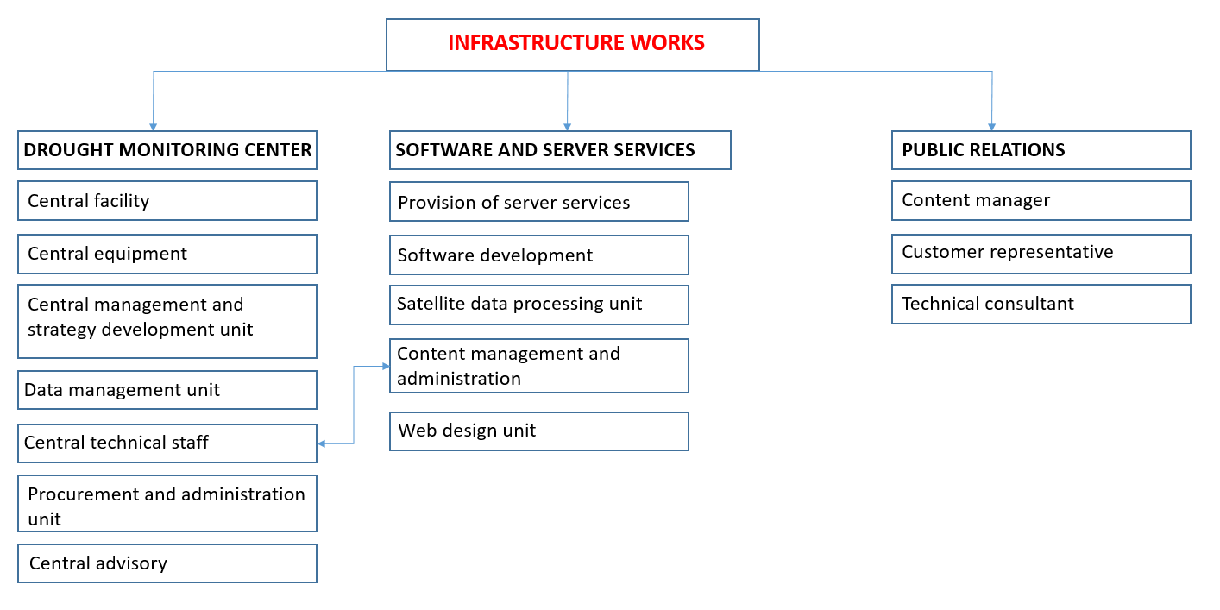
Figure 1. Drought Monitoring System Infrastructure Works Flow Chart

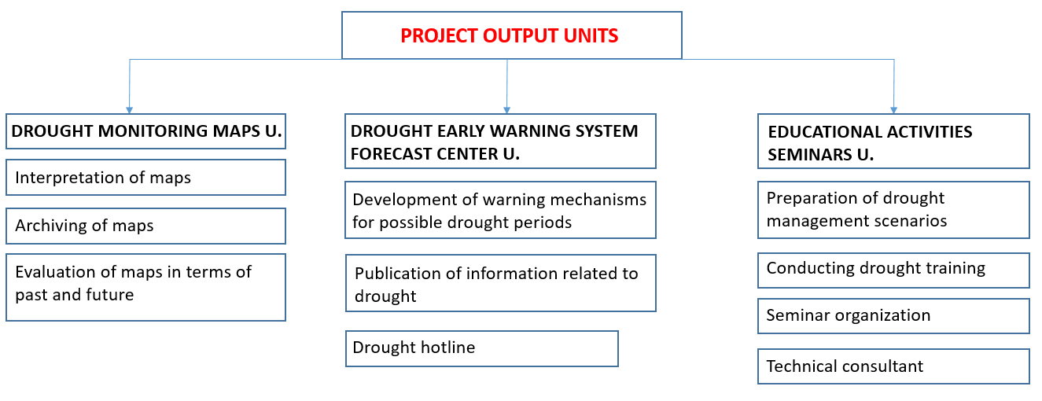
Figure 2. Drought Monitoring System Output Units Flow Chartd

ANNEX 2
Minimum Field Equipment Determined in the Preliminary Investigation Report

No | Work Item | Amount
1 | Supply of fully equipped weather stations (temperature, precipitation, solar radiation, snow, dew point, wind) (7 parameters) and transfer of data to the center | 20
2 | Supply of evapotranspiration meters with automatic evaporation and transfer of data to the center | 3
3 | Supply of soil water content monitoring station (humidity sensor 90 cm/10 cm apart) and transfer of data to the center | 20
4 | Supply of a current observation station (limnigraph with radar sensor) and transfer of data to the center | 6
5 | Drilling of a new AGE well | 35
6 | Transfer of measurement results of existing and new AGE wells to the center (3 parameters) | 90
7 | Opening of new groundwater observation stations (at the points where meteorological stations will be established) | 20
8 | Transfer of measurement results of existing and new groundwater observation wells to the center (3 parameters) | 1258
9 | Installation of a lake observation station (limnigraph with pressure sensor) and transfer of data to the center | 3
10 | Satellite image processing software | 1
11 | System software | 1
12 | Other (needs such as training, reporting, workshops, sustainability, etc.) | -
13 | Groundwater chemical analysis | 80

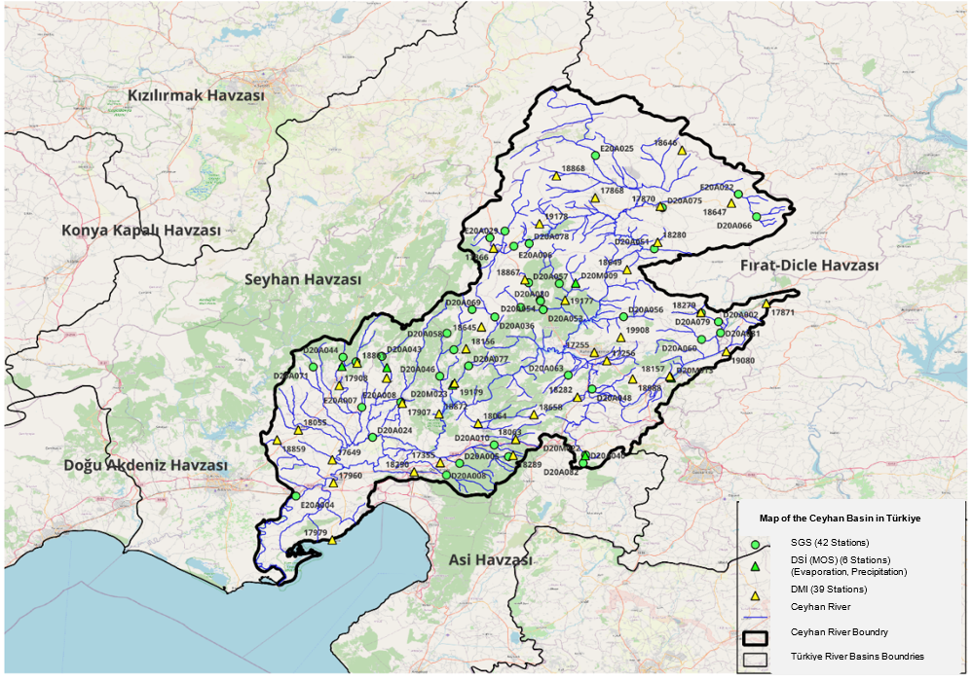
Figure 4. Current Observation Stations (AGI) and Meteorological Observation Stations (MGI) Locations in the Ceyhan Basin
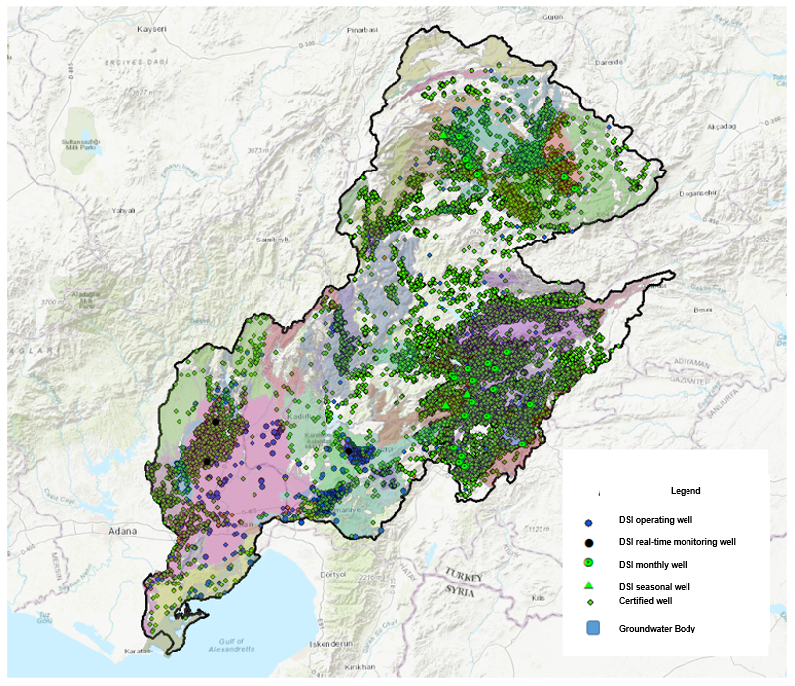
Figure 5. Locations of Existing GW Observation Wells in the Ceyhan Basin

Definitions
- Ministry: Ministry of Agriculture and Forestry.
- Contracting Authority (CA): DSİ (Directorate General of State Hydraulic Works) / Operations and Maintenance Department.
- Consultant: Refers to the proposer to whom the contract has been awarded and with whom such contract has been signed.
- Advisor: Refers to the field-expert who are experts in their fields, engaged in either a partial or full-time basis to contribute insights and inform the decision-making process within the scope of the service, ensuring effective final decisions.
- Basin: It is the collection area of water according to the point where it flows from the water separation line to the sea in river basins, and the final point where it is collected from the water separation line in closed basins. The pilot basin which is the concern of this ToR is the Ceyhan Basin.
- Sub-basin: It is the collection area of the tributaries connected to the river that discharge the waters of the basin into the sea, or the lakes that feed the river or the tributaries and miscellaneous waters that feed the lakes.
- Drought: It is a natural phenomenon that adversely impacts land, water resources and production systems and causes serious hydrological imbalances as a result ofsignificant reduction of precipitation below the normal recorded levels.
- Abbreviations
- AGI: Stream Gauging Station
- SGS: Stream Gauging Station
- ATHOM: Flow Estimation and Basin Optimization Model
- ET: Evapo-transpiration
- DSİ: General Directorate of the State Hydraulic Works
- GIS: Geographic Information System
- Max: Maximum (the most)
- Min: Minimum (the least)
- TSMS: Turkish State Meteorological Service
- DGWM: Directorate General of Water Management
- GDAR: General Directorate of Agricultural Reform
- USDM: U.S. Drought Monitoring System
- WMO: World Meteorological Organization
- GW: Groundwater
- UGW: Underground water
- MOS: Meteorological Observation Station
- SPI: Standardized Precipitation Index,
- SPEI: Standardized Precipitation and Evapo-transpiration Index
- PNI: Percent of Normal Index,
- PDSI: Palmer Drought Severity Index,
- SWSI: Surface Water Supply Index,
- SRI: Standardized Runoff Index,
- SWI: Standardized Water-level Index,
- EDDI: Evaporative Demand Drought Index,
- CWSI: Crop Water Stress Index,
- SVHI: Satellite Vegetation Health Index,
- VCI: The Vegetation Condition Index.
- USGS: U.S. Geological Survey
- ToR: Terms of Reference
- DSPDI: Daily Stream Flow Percentiles Drought Index

https://documents1.worldbank.org/curated/en/099060724003066059/pdf/BOSIB-e9585c2f-de89-4fe5-9c3d-3cba7e38e366.pdf
https://droughtmonitor.unl.edu/CurrentMap.aspx
https://www.drought.gov/current-wconditions

